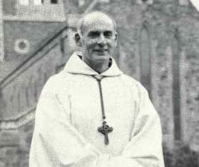
DOM AMBROSE SOUTHEY
Abbot General of the Cistercian Order of the Strict Observance 1974 to 1990

In the late morning of August 24, 2013, Dom Ambrose Southey died.

Dom Ambrose was born January 22, 1923 in Whitley Bay (Great Britain). He entered Mount Saint Bernard in 1940 and made solemn profession in 1945 and was ordained a priest in 1948.

He studied Canon Law in Rome from 1951 until 1953. He was named Prior of Mount Saint Bernard and elected abbot of that Community, 9 July, 1959.

He was elected Abbot General of the Order May 7, 1974, and remained in office until the General Chapter of 1990. During that Chapter Dom Ambrose presented his resignation from the ministry of Abbot General.
Later he was named Superior ad nutum of Bamenda Abbey (Cameroun) which he served from 1993 until 1996, and Superior ad nutum of Scourmont Abbey (Belgium) 1996 until 1998. Dom Ambrose later accepted the ministry of Chaplain for the Community of Vitorchiano and remained there until he returned definitively to his community of Stability, Mount Saint Bernard.

He was 90 years old, had been in monastic life for 71 years and 64 years a priest when the Lord called him. Dom Ambrose is remembered for his generous personal service to all our Communities and his interest in developing the Constitutions of the Order.
(www.ocso.org)

