Lectio divina – Sacred Reading
Lectio
We were created to know, love and serve God here on earth, and to see and enjoy him forever in heaven, but we cannot love a person unless we know that person. We come to know the person of Christ from his own words and what others have written about him in the Bible.
The facts that the Second Person of the Blessed Trinity was called the 'Word' (Jn 1:1) and that one of the few words spoken by the Father was 'Listen to him' (Mt 17:5) leave us in no doubt about the importance of lectio divina or prayerful reading. The aim of lectio divina is to encounter Christ, for he has the 'words of eternal life' (Jn 6:67), he was 'sent to bring the good news to the poor' (Lk 4:18) and 'to know him is eternal life'. (Jn 17:3)
Practice
Literacy is not absolutely essential to attain the end of lectio as listening to readings and homilies, lectures and conferences and reciting psalms and other texts by heart can make up for actual reading. Periods of Community reading as at Mass, Divine Office, meals and before Compline (the final Hour of the daily Divine Office) have always been practiced in religious communities.
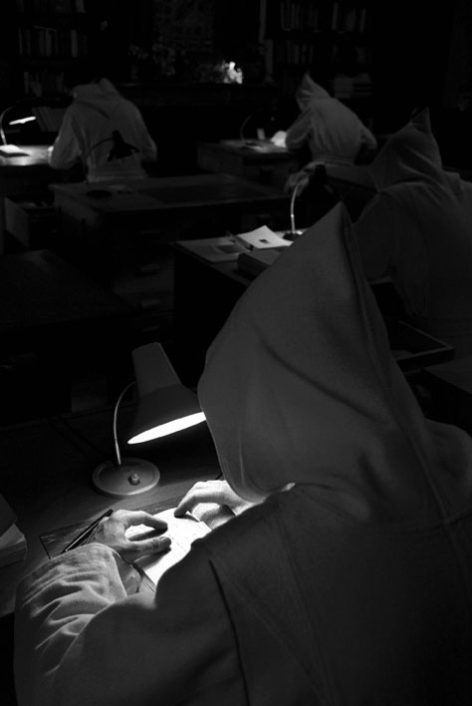
Over the years the amount of such reading adds up to a surprising amount of time. Community reading also ensures that the more desirable books are available to a greater number of people. In recent centuries in the Cistercian tradition, in some monasteries, reading was done in the Scriptorium (writing room). Reading in common, even though each one may read their own book in private, does add something to the exercise.
It is interesting that neither scriptorium nor library were budgeted for in the traditional Cistercian monastic plans. So to gain the benefits of lectio divina it is not absolutely necessary to be able to read.

Lectio divina – Sept-Fons (photo: Bruno Rotival)

Every Mass, every sacrament, is accompanied by Scripture readings so by simply listening attentively to them we are doing lectio. Some of the medieval scribes were illiterate and for that reason were hired to copy confidential documents.

Lectio Divina & Prayer
The distinction between prayer and lectio is not clear cut, on the other hand the distinction between lectio and study is; since the aim of study is often a degree while the aim of lectio is always worship. Lectio is to be done with the heart rather than with the head for the words of the Lord are spirit and life. As the Our Father is taken directly from the gospel of Saint Mathew (6:9-11), every time we hear it or say it we are in a way doing lectio divina as well as praying.
As in prayer a reverent approach is essential for lectio. It should be begun with the Sign of the Cross. Reverence for the Word should be shown even to the written word. At solemn Masses the Gospel book is accompanied by lights and incense and is kissed by the Deacon who prays after proclaiming the Gospel: 'By the words of the Gospel may my sins be blotted out.' And the people acclaim, 'Praise to you Lord Jesus Christ,' for he is present in his Word. A renowned biblical scholar used say he would not place his Bible where he would not place a chalice and certainly few would advocate a plastic cup for offering Mass.
Curiosity has always been a professional hazard of the reader as it is the intention more than anything else that makes reading lectio. To ensure a pure intention in the Cistercian tradition monastics were encouraged to begin their lectio on their knees. Worship should be the natural outcome of lectio. To kneel at the conclusion of the exercise is also a very wholesome custom for in Scripture, especially in the writings of Saint John encountering Christ nearly always leads to adoration.

Rule of St Benedict
Saint Benedict in his rule synthesized the monastic customs of his time. His three pillars for the monastic life are the Opus Dei (Divine Office), Lectio Divina and Work even though he also legislated for people who could not read, providing for them by community reading. He recommends that everything be done per ducatum Evangelii (with the Gospel to lead).
He orders that the novice should truly seek God Ut reverum Deum quaerat and where can he be found if not in his Word since this Word 'is all and is in all' (Col 3:11)? Saint Benedict wishes that 'God be glorified in all things' ut in omnibus glorificatur Deus (RB 57:9, 1Pet 4:11). But God must be found first in before he can be glorified. As the poet wrote, there are, 'sermons in stones, books in the running brooks and good in everything.'
St Benedict legislated for about 4-5 hours every day for each of his three main exercises. He recommends early morning reading and was practical enough to realize the some people would find it difficult and would have to be encouraged to keep at it. (RB 48) Reading was done in the cells or in the cloisters, in the church, refectory and chapter room and even in the dormitory though Benedict warns readers not to disturb others.
This was one of the reasons for the monastery being a house of silence for it was a house of reading and prayer. When done in the cloister the northern cloister running parallel to the church was usually the reading cloister as it got most sun and was thus brighter and warmer. Bookstands and reading pulpits are features of all monastic architecture and good acoustics were required in all monastic spaces.
Scripture
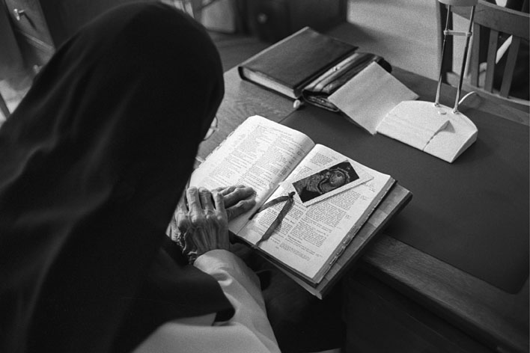
As the adjective divina indicates, the book par excellence for lectio is the Bible. Scripture itself frequently mentions reading lectio. Nehemiah (8:2-10) and the eunuch from Ethiopia (Acts 8:28) are but two very good examples. 'Jesus said: "If you make my word your home you will indeed be my disciples; you will come to know the truth, and the truth will set you free"' (Jn 8:31-32).
”Sacred Reading” (Abbey of Altbronn, photo: Bruno Rotival)
Saint Paul wrote to the Romans: '... all these things which were written so long ago were written so that we, learning perseverance and the encouragement which the scriptures give, should have hope.' (Rom 15:4)
To the Corinthians: 'Now all these things happened to them by way of example, and they were described in writing to be a lesson for us, to whom it has fallen to live in the last days of the ages.' (1 Cor 10:11)
To the Ephesians: '[God] made known to me by a revelation the mystery I have just described briefly - a reading of it will enable you to perceive my understanding of the mystery of Christ (Eph 3:3-4).
To the Philippians: 'Fill your minds then with things that are true, honourable, upright and pure; things that are lovely, admirable, good and praise-worthy ... and the God of peace will be with you (Phil 4:8-9).
To Timothy: 'Until I arrive devote yourself to reading' ... Attende lectioni (1 Tim 4:13). 'All scripture is inspired by God and useful for refuting error, for guiding people's lives and teaching them to be upright.' (2 Tm 3:16)
Saint Peter: 'I have written to you, trying to awaken in you by my reminder an unclouded understanding.' (2 Pet 3:1)
Text: Mt St Joseph Abbey, Roscrea, Ireland (www.msjroscrea.ie)

